Curriculum Vitae

Personal Information
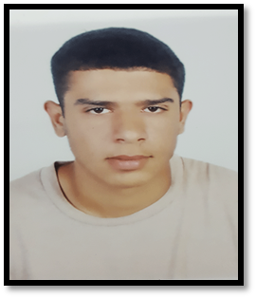
Name : Salman Saeed Ali Albaqqali
CPR :990105806
Nationality : Bahraini
Date of Birth : 14/01/1999
Place of Birth : Jidhafs
Sex : Male
Marital Status : Single
Religion : Moslem

Contact Details

Address : House 542, Round 2120, Jidhafs 421
Mob : 36702712

Objective

To use my skills in the best possible way for achieving the company’s goals.

Education
  - : Jidhafs industrial boys school
Secondary industrial Certificate

Languages
English : Understanding
Arabic : Fluent written& spoken.

Skills
Computer skills: Ms office, Internet (Abel to use Internet), Typing (Arabic) .
communication skills, , computer literacy.

Work Experience
No Source

Reference
No Source

